**Key: Answers**

**Insertion Test**

**Instructions**: Identify the current node in each step and what rule you would apply if any. Show all of your work. (Nodes with a double circle are red, and x is the current node)

**Rules:**

* Do nothing (keep traversing down)
* Color flip
* Single rotation
* Double rotation
* Insertion (simple insertion)
* Recolor root black

1. Insert 60: 1pts.

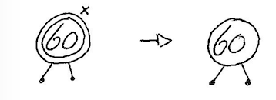

1. Insert 50 & 70: 2 pts. (Continue on same tree)

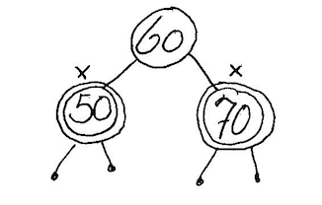

1. Insert 40 & 41: 5 pts. (Continue on same tree)

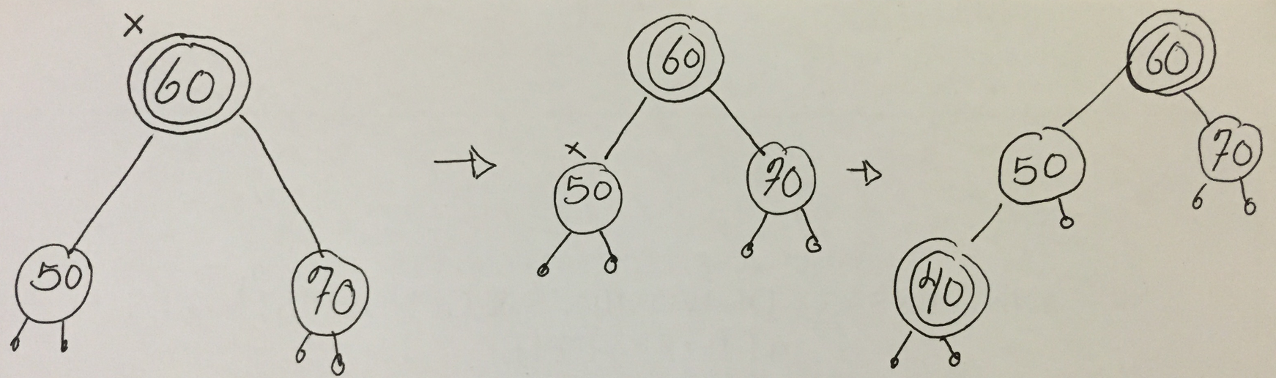

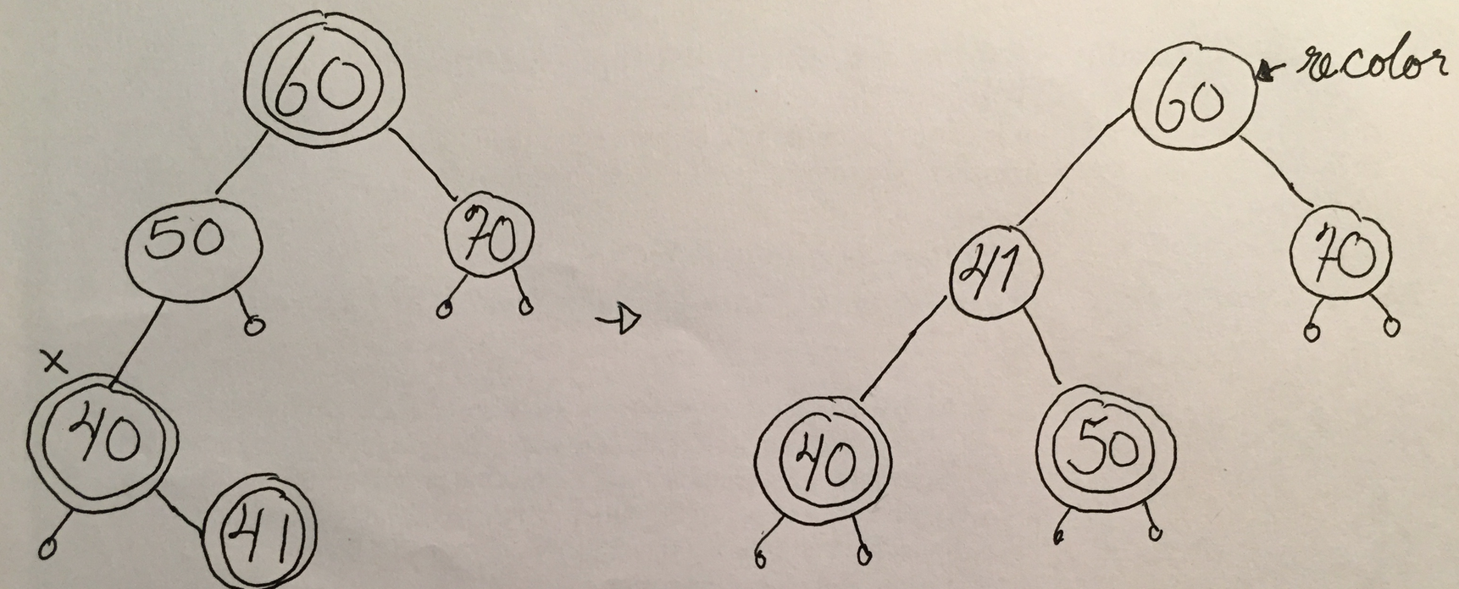

1. Insert 1 & 99: 4 pts.

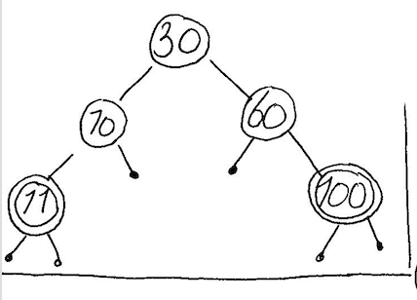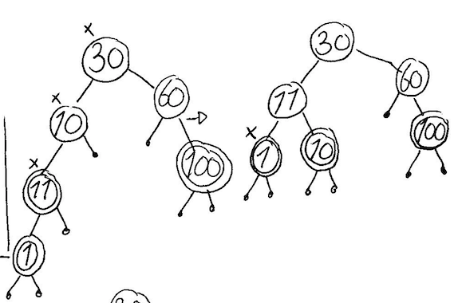

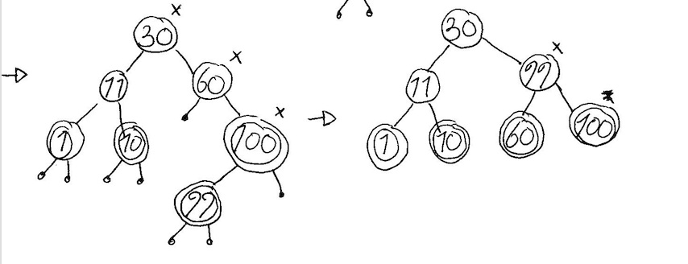

1. Insert 10: 3 pts.

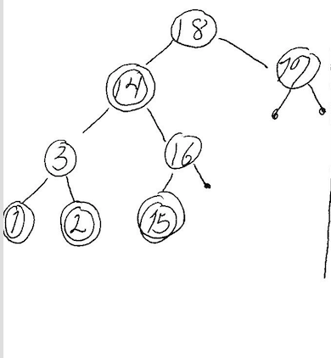

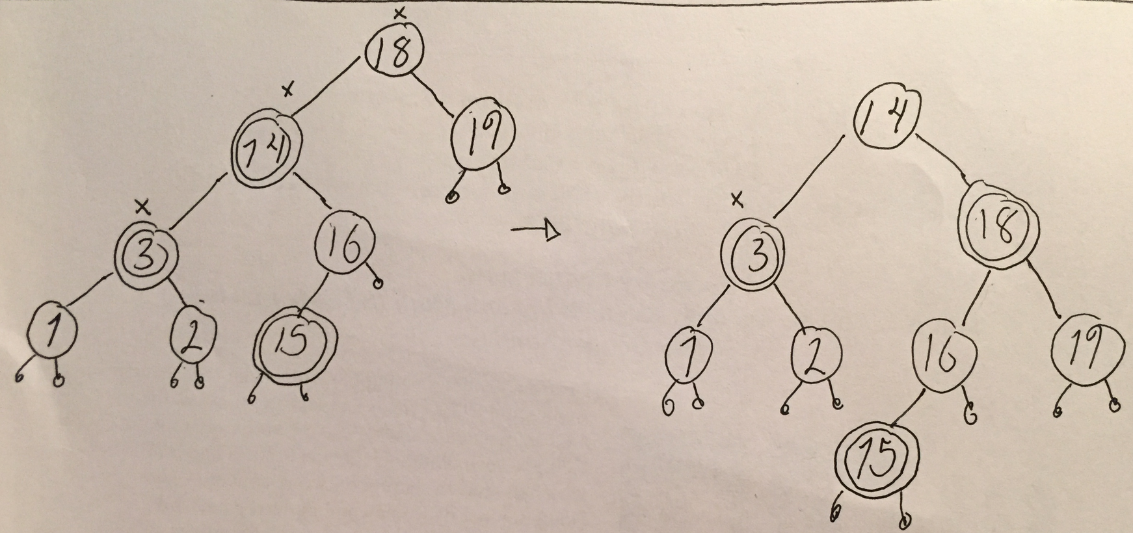

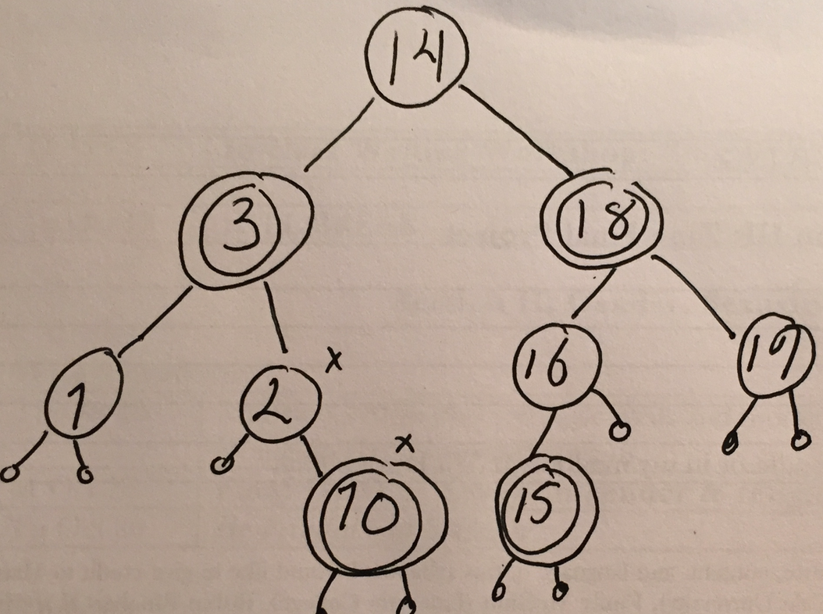

1. Insert 18: 3 pts.

